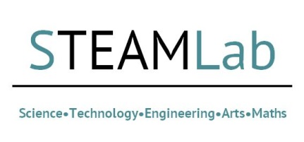
Virtual Problems STEAMLab application Form: 6th June 2018
The Research and Knowledge Exchange office are hosting a BU STEAMLab. The purpose of this one day event is to bring academics together from the M3 network alongside selected stakeholders to explore a key area of research development. For this event, we will be considering the ‘Future Audiences’ in the widest sense. It is expected that a number of potential research ideas will emerge and will then be supported by RKEO’s Research Facilitators, leading towards a grant application.
By applying to attend this facilitated workshop, you are committing to attend for the full day (c. 9-4 on Wednesday 6th June 2018, to include a networking lunch). If you are unable to attend for the whole event, please do not apply to attend. This is due to the format of this workshop being one that builds throughout its duration.
Please complete the short application form below and submit this to Dianne Goodman, RKEDevFramework@bournemouth.ac.uk ,RKEO’s Funding Development Team Co-ordinator by 18/1/18
Name
Research Area
Faculty
University/Company

Please outline what you will bring to this event (skills, previous bidding experience, networks etc):

