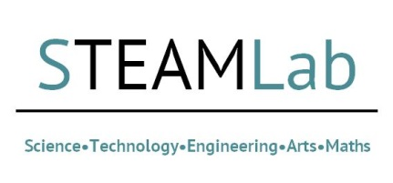
ASV Virtual STEAMLab application Form: 24 February 2021
Research, Development & Support (RDS) are hosting a BU pilot Virtual STEAMLab. The purpose of this 2-hour long event is to bring academics and other stakeholders together to explore some key societal, health, environmental and cultural challenges in 4 core areas of ASV research development and practice. It will also be the first of a series of mini virtual ASV STEAMlabs to be held in the course of 2021.
This first STEAMlab will introduce and address our four core priority areas for the strategic development of ASV cross-faculty, multi-disciplinary collaborations across BU. These 4 areas are: Virtual Production, Digital Health, Environment in Crisis, and Virtual Heritage.
By applying to attend this facilitated workshop, you are committing to attend for the full two hours on 24 February 2021, from 1 – 3 pm. If you are unable to attend for the whole event, please do not apply to attend. This is due to the format of this contracted virtual workshop being one that builds throughout its duration. Please complete the short application form below and submit this to Nicolette Barsdorf-Liebchen at nbliebchen@bournemouth.ac.uk.
This information may also be used to help select colleagues for Scramble events at short notice. Please select here if you do not want to be contact for these events. Yes/No
Name
Research Area
Faculty
University/Company

Please outline what you will bring to this event (skills, previous bidding experience, networks, any particular research idea/s you wish to pursue):

