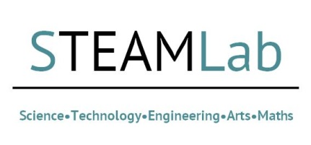
Medical Science Virtual STEAMLab application Form: 22nd July 2021, 2pm-4pm
Research Development & Support (RDS) are hosting a Virtual STEAMLab. The purpose of this 2-hour long event is to bring academics and other stakeholders together to explore some key issues/topics in Medical Science. It will be the third of a series of mini virtual STEAMlabs to be held in the course of 2021.
By applying to attend this facilitated workshop, you are committing to attend from 2pm – 4pm on 22nd July, and contribute to pre-event discussions on the Padlet platform. Please complete the short application form below and email this form to Lisa Andrews at andrewsl@bournemouth.ac.uk.

This information may also be used to help select colleagues for Scramble events at short notice. Please select here if you do not want to be contact for these events: ☐Yes or ☐No

Full Name
Research Area
Faculty
University/Company

Please outline what you will bring to this event (skills, previous bidding experience, networks, any research idea/s you wish to pursue):

