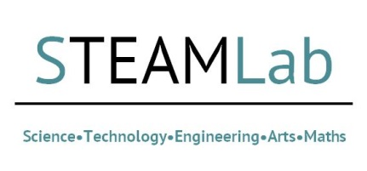
Global Challenges STEAMLab 6/7/21
For this event, we will be considering the ‘Global Challenges’ in the widest sense. It is expected that a number of potential research ideas will emerge and will then be supported by BU RDS Research Facilitators and the Global Engagement Hub, which will lead towards research grant funding applications.
If you are unable to attend for the whole event, please do not apply to attend. This is due to the format of this workshop being one that builds throughout its duration.
Please complete the short application form below and submit this to Dr. Sarah Price, GlobalBU@bournemouth.ac.uk , by 24/6/21.
Name
Research Area
Faculty
University/Company

Please outline what you will bring to this event (skills, previous bidding experience, networks etc):

