Participant Information Sheet
Title of research project

Does neuromuscular electrical stimulation (NMES) improve knee extensor muscle endurance in healthy older adults? A feasibility study.

Invitation to take part
You are being invited to take part in a research project. Before you decide it is important for you to understand why the research is being done and what it will involve. Please take time to read the following information carefully and discuss it with others if you wish. Ask us if there is anything that is not clear or if you would like more information. Please take time to decide whether or not you wish to take part.

Who is organising the research?
The study is being organised by a PhD student at Bournemouth University.

What is the purpose of the project?
To understand whether neuromuscular electrical stimulation (NMES) can increase muscle endurance of the quadriceps in healthy older adults.

What is neuromuscular electrical stimulation?
Neuromuscular electrical stimulation sends electrical impulses to nerves. This causes muscles to contract. Doing so can increase muscle strength and offset the effects of muscle disuse. It is often use to improve muscle function and to build strength before or after surgery or following a period of disuse. It’s most commonly used with individuals are unable to perform voluntary exercise.

The device used in this study is a Microstim neuromuscular stimulator, made by Odstock Medical Ltd. It is the size of a mobile phone and is connected to the muscles in your leg using two self-adhesive pads called electrodes, like in the picture below.

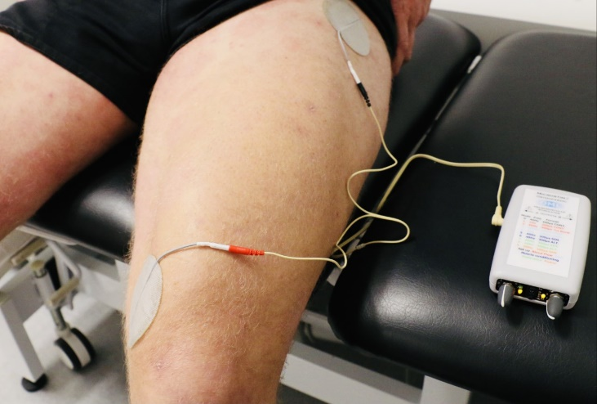
Why have I been chosen?
You are asked to take part in this study because you are an adult aged 60 or over and in good general health. If you agree to take part, you will be one of 12 participants recruited for this study.

You will be unable to take part if you:
- Have a neurological disease affecting your walking ability (Parkinson’s, cerebral palsy, multiple sclerosis, other spasticity);
- Are receiving an active medical treatment for a musculoskeletal disorder;
- Are fitted with a pacemaker or other active medical implant;
- Suffer from uncontrolled epilepsy;
- Have sepsis or osteomyelitis;
- Have a skin condition that prevents the use of self-adhesive electrodes;
- Are not able to produce an involuntary muscle contraction of the quadricep muscles using NMES (tested at your assessment);
- Are participating in any form of muscle strengthening programme aimed at improving muscle strength of endurance;
- Are unable to provide informed consent;
- Are unable to complete study follow up.

Do I have to take part?
It is up to you to decide whether or not to take part. If you do decide to take part, you will be given this information sheet to keep and be asked to sign a participant agreement form. You can withdraw from participation during the study at any time and without giving a reason. If you decide to withdraw, we will usually remove any data collected about you from the study. Once the study has finished you may still be able to withdraw your data up to the point where the data is analysed and incorporated into the research findings or outputs. At this point your data will usually become anonymous, so your identity cannot be determined, and it may not be possible to identify your data within the anonymous dataset. Withdrawing your data at this point may also adversely affect the validity and integrity of the research.

What would taking part involve?
Eligible participants will be invited to attend a baseline assessment at the Orthopaedic Research Institute, Bournemouth University. Data will be collected on knee extensor strength and endurance, functional performance, daily activities and quadriceps cross-sectional area. You will be shown the NMES device and instructed how to operate it. You will then complete six weeks of NMES training at home. You will be contacted by telephone throughout the study, to have your treatment reviewed. You will be asked to record your NMES use in a diary. After 6 weeks, you will be invited to attend a final assessment where your baseline measures will be repeated. In addition, you will be asked to provide feedback on your experience of using the device.

What are the advantages and possible disadvantages or risks of taking part?
Research evidence conducted with a variety of patient groups and athletes has found that NMES can improve muscle size and strength. However very little work has been done in the area of NMES for improving muscle endurance in older adults. We anticipate NMES will increase muscle endurance, however we cannot guarantee this. You will not be paid for your participation in this study. However, we are able to send you a £20 gift card to say thank you for your time. We will also provide you with a report on your lower limb strength. There may be some discomfort from the stimulation and there is a small risk of skin irritation.

Covid-19 considerations
Personal protective equipment will be worn by the researcher collecting data. In addition, social distancing will be adhered to where possible. Face-to-face contact will be limited, and all lab equipment will undergo extensive cleaning in line with the Orthopaedic Research Institute’s standard operating procedure for the decontamination of the environment and equipment during the Covid-19 pandemic. Finally, all participants will be screened for Covid-19 during their initial telephone consultation, and upon arrival at the Orthopaedic Research Institute.

What type of information will be sought from me and why is the collection of this information relevant for achieving the research project’s objectives?
We will measure your weight, height and record any relevant past medical history. We will ask you to complete some strength tests using a muscle testing machine and look at the size of your quadriceps muscle using an ultrasound machine. We will also test your functional ability, which will include getting up and down from a chair, walking and climbing stairs. We will collect data on your adherence to the intervention. At your follow up appointment, we will ask for your feedback on the intervention. This data will be used to draw conclusions about the effectiveness of NMES strengthening quadriceps in healthy older adults.

How will my information be kept?
All the information we collect about you during the course of the research will be kept strictly in accordance with current data protection legislation. Research is a task that we perform in the public interest, as part of our core function as a university. Bournemouth University (BU) is a Data Controller of your information which means that we are responsible for looking after your information and using it appropriately. BU’s Research Participant Privacy Notice sets out more information about how we fulfil our responsibilities as a data controller and about your rights as an individual under the data protection legislation. We ask you to read this Notice so that you can fully understand the basis on which we will process your information.

Publication
You will not be able to be identified in any external reports or publications about the research without your specific consent. Otherwise your information will only be included in these materials in an anonymous form, i.e. you will not be identifiable.

Research results will be published in an academic journal, and in the PhD thesis in which the study is a part of.

Security and access controls
Bournemouth University will hold the information we collect about you in hard copy in a secure location and on a Bournemouth University password protected secure network where held electronically.

Except where it has been anonymised your personal information will be accessed and used only by appropriate, authorised individuals and when this is necessary for the purposes of the research or another purpose identified in the Privacy Notice. This may include giving access to BU staff or others responsible for monitoring and/or audit of the study, who need to ensure that the research is complying with applicable regulations.

Retention of your data
All personal data collected for the purposes of this study will be held for 5 years from the date of publication of the research or presentation of the results to the sponsor, whichever is later/ 5 year after the award of the degree. Although published research outputs are anonymised, we need to retain underlying data collected for the study in a non-anonymised form for a certain period to enable the research to be audited and/or to enable the research findings to be verified.

Contact for further information
If you have any questions or would like further information, please contact Louise Burgess (PhD student) on 01202 961651 or lburgess@bournemouth.ac.uk or Ian Swain (supervisor) on 01202 964010 or iswain@bournemouth.ac.uk.

In case of complaints
Any concerns about the study should be directed to Vanora Hundley, Faculty of Health and Social Sciences, Bournemouth University by email to researchgovernance@bournemouth.ac.uk.

Finally
If you decide to take part, you will be given a copy of the information sheet and a signed participant agreement form to keep.

Thank you for considering taking part in this research project.

